Background:
Diageo, a global company owning extraordinary brands like Gordon's Gin, goes beyond crafting exceptional beverages, they reframe and celebrate what it means to drink with moderation. The brand recognises its responsibility to tackle the harmful use of alcohol. Through their 10-year action plan and their DRINKiQ programme they promote positive drinking and educate people on how to celebrate more responsibly by changing attitudes towards drinking alcohol.
Challenge:
Positioning Gordon's Gin as the choice for young adults who seek a balance between enjoying vibrant social experiences and making responsible choices when it comes to drinking.
Problem: 30% of youngsters are affected by binge drinking and have experienced a blackout at least once before the age of 24 wasting about 2 years of their life due to hangovers. Google Trends revealed peak search volumes for hangover-related queries during Christmas & New Year and weekly Sundays, highlighting the hazardous impact of alcohol consumption on weekends.
Target audience: 18-24s in Hungary, who are socializing actively and seeking social interactions.
1. Social butterflies: Actively engage and post on social media, and contribute to positive social change.
2. Culturally curious: Thirst for cultural experiences, Seeking diversity in arts, music, and creative expression.
They gravitate towards brands that share their values and make a positive impact on society.
Insight: While memories of a night out may fade, the painful aftermath lingers on.
Strategy: Gordon's Gin shows people how to celebrate every moment of life — without hangovers.
Marketing communication objective:
Engaging people in meaningful conversations, shifting existing social norms around drinking in Hungary.
Reaching one billion people globally with the message of moderate celebration by 2030
Message: Gordon’s Bin- Avoid the wasted days caused by hangovers #BinTheHangovers
Idea: Introducing Gordon's Bin - an AI-generated journal to discard the memories of hangovers.
- Developing a website where users can share their hangover experiences and what they miss out on as a result.
- With generative AI (eg. Midjourney, DALL-E), the app generates images from natural language descriptions. Namely we turn the user stories into "prompts" then to some surrealistic images and artworks.
- Users can share their artsy creations with a dedicated hashtag #BinTheHangovers
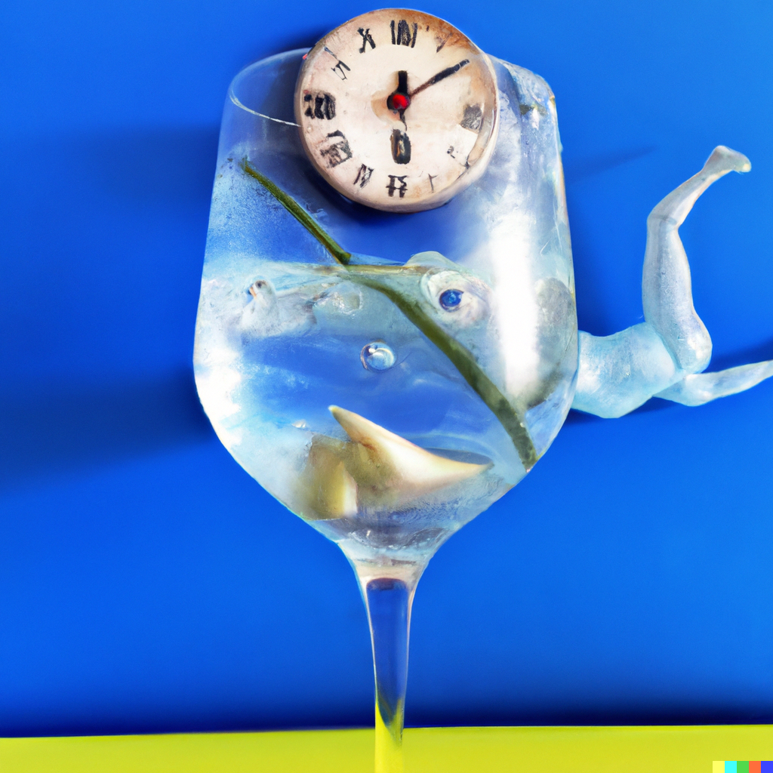 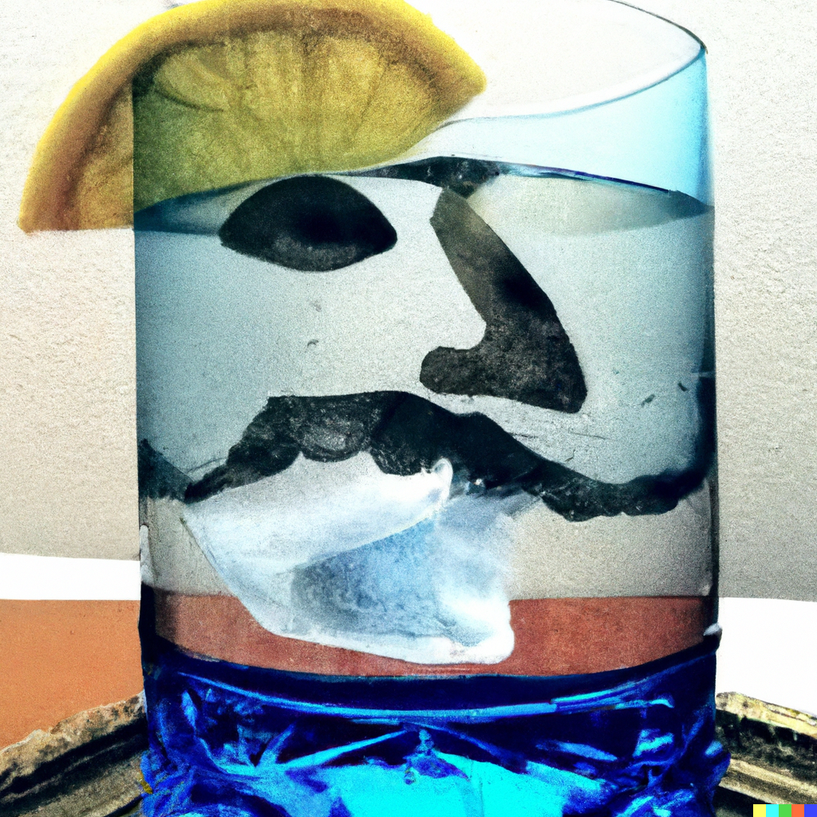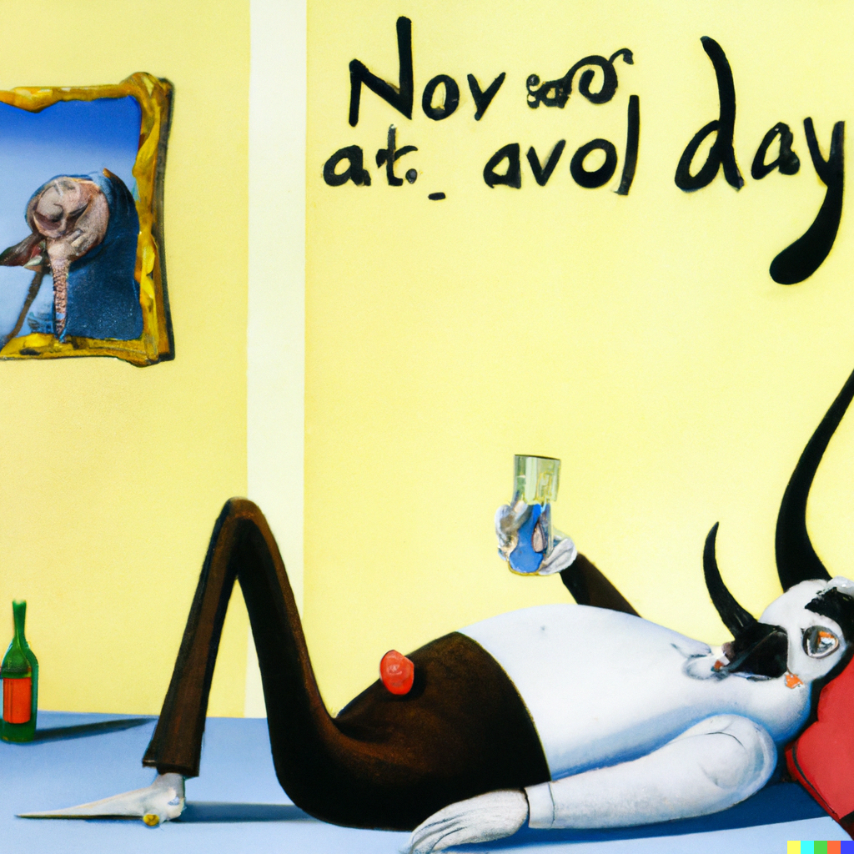 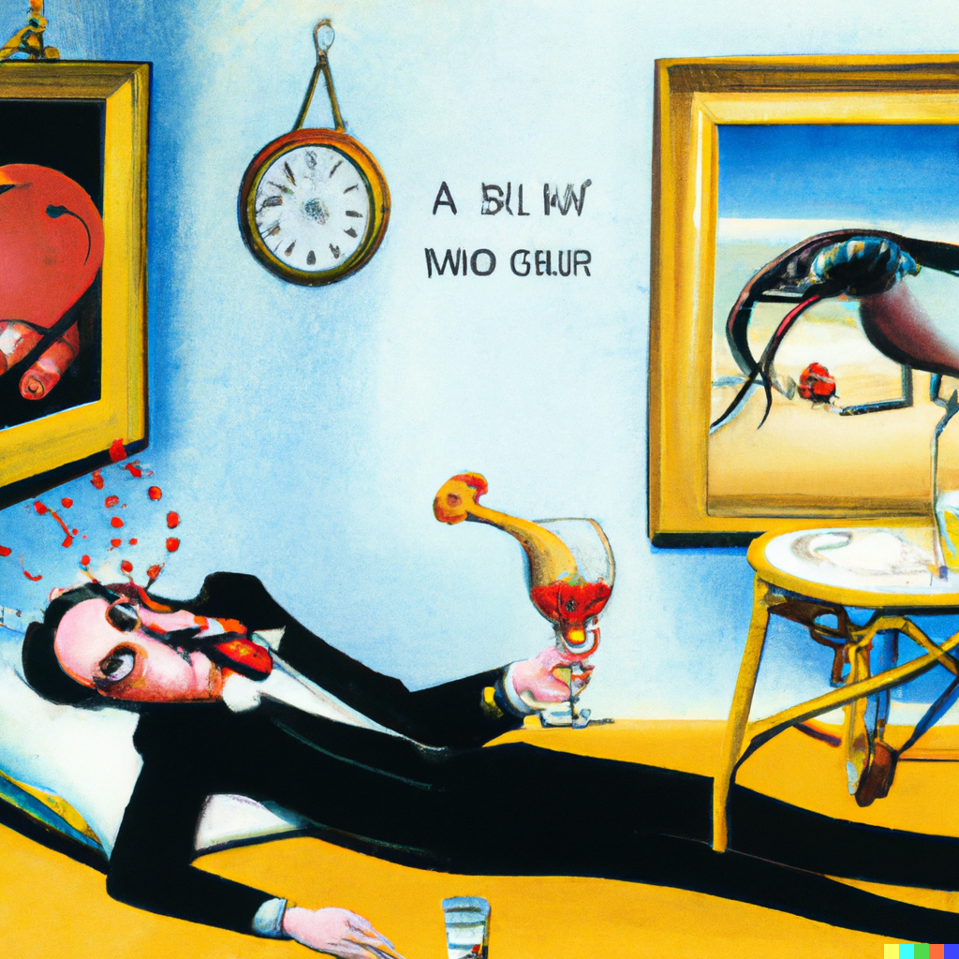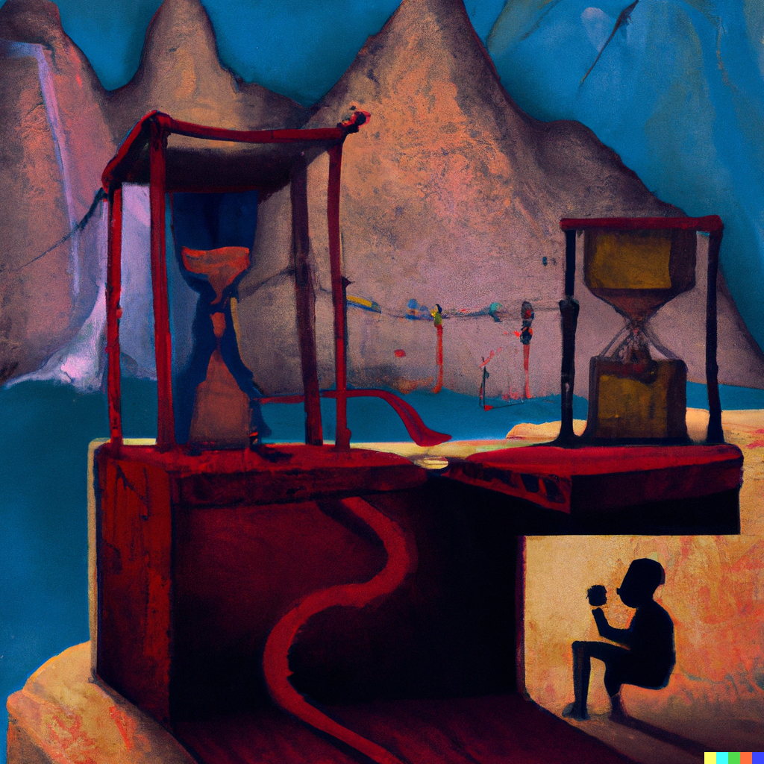
(My hangover day inspired by Salvador Dalí's "The Persistence of Memory.")

Campaign phases:
1.) Awareness & engagement: We partner with influencers to raise awareness and educate the audience, who will share embarrassing hangover stories accompanied by unique AI-generated images. This campaign entertains, sheds light on the issue and encourages education and discussion.
2.) Gordon's Gin limited edition: Gordon's Bin creative packaging will feature educational messages based on the midjourney images, which serves as a reminder of the consequences of excessive drinking while promoting responsible consumption.
3.) Education:
- PR stunt: Collab with leading Hungarian news portals. We'd place banners on the news portals, leading to a special landing page, where all the news are about an alternative future. We will show how much could happen while binge drinkers spend their time focusing on curing their hangovers.
- OOH: CLP ads generated from the influencers' midjourney stories; ambient ads on Sziget festival
4.) Engagement: To further engage the audience, we’ll host an exhibition during Dry November, showcasing the best mid-journey images. Users who have shared their creations with the hashtag will receive free entry. This exhibition celebrates creativity and sparks dialogue around the issue of hangovers and responsible drinking.
5.) Global fame: Building upon the success of the campaign, we will collaborate with renowned galleries to exhibit the midjourney images alongside Salvador Dalí's original masterpiece, "The Persistence of Memory." This collaboration will elevate the conversation around responsible drinking and offer a thought-provoking juxtaposition between the consequences of excessive alcohol consumption and the surrealism of Dalí's art.
Agency task:
Create an expansive creative platform for "Gordon's Bin" that amplifies the campaign's message, reaching diverse target audiences and inspiring their active participation in the initiative to shift attitudes towards excessive drinking and promote moderation.
Channels & Deliverables:
Campaign website/platform for AI-based image generation, storytelling, education.
Influencers& SocMe comm: Identifying the right influencers & planning the SocMe communication (Tiktok, Instagram, Snapchat, Facebook, and YouTube)
Packaging design for Gordon's Bin
OOH
PR stunt: Digital ads and PR articles for educational content & promoting the exhibition
Timing:
- Campaign launch, awareness: 2023 June 16 (the end of school year)
- Product launch: 2023. July 1 (start of outdoor festival season)
- Education: 2023 Aug 10 – Aug 15, 2023 (Sziget festival)
- Engagement: 2023 Nov 1– 30
- Post-campaign phase: 2023 Dec- 2024 Jan
Budget: 40 000 000 HUF + VAT
KPIs: 140 000 000 impressions / OTS overall

